Q2 2026 Workforce Review — Evidence Package
Customer operations · Northwind Health Group (fully synthetic project data) · Reporting period Q2 2026 (1 Apr – 30 Jun 2026), Q1 2026 baseline
Prepared by: HR Analyst · Sources: prepared_workforce_workbook.xlsx, metric_definition_pack, workforce_question_brief, ai_assisted_interpretation, power_bi_starter_report (specification) · Companion file: workforce_summary.csv (submitted separately)

1. Workforce Question and Business Context
Item | Detail
Leadership question (workforce_question_brief) | “Which region needs the most immediate HR follow-up this quarter, and what evidence-proportionate action should we recommend to the regional leader?”
Staffing-pressure framing (project scenario) | Which workforce pattern is most decision-relevant for current staffing pressure: headcount movement, recruiting throughput, attrition concentration, compensation patterns, or a combination of factors?
Reporting periods | Q1 2026 = baseline (Q1 end headcount, supplied as Begin_HC).  Q2 2026 = current (1 Apr – 30 Jun 2026). Point-in-time headcount date: 30 Jun 2026.
Population and segments | Four regions: North, Central, South, West. Compensation is compared within Job Level L3 (sample).
Function under focus | Escalations Ops (Support division)
Business-context measure | Backlog per FTE — Q2 average, Escalations Ops only. Used as operating context, not as workforce evidence.
Interpretation standard | Descriptive only. Nothing in this package is presented as proof of cause, discrimination, policy failure or legal risk.
Source: workforce_question_brief; prepared_workforce_workbook.xlsx › Business_Context!A3:B10; project scenario.

2. Metric-Definition Check
Each governing definition was read in metric_definition_pack and checked against the workbook before any value was interpreted.

2a. Governing definitions verified
Metric | Approved definition | Verified against workbook | Rule that changes interpretation
Q2 End Headcount | Distinct EmployeeID active on 2026-06-30. | End_HC reconciles to Begin_HC + Joiners + Transfers_In − Leavers (vol. + invol.) − Transfers_Out in all four regions (residual 0). | Point-in-time count on the period-end date, not an average.
Headcount Change | Q2 End HC − Q1 End HC; Q1 End HC = Begin_HC. | Region_Summary HC_Change = End_HC − Begin_HC for every region. | Change is measured Q1 end → Q2 end.
Screened-to-Interview Conversion | Σ interviewed ÷ Σ screened, per region, Q2. | Recalculated from counts: 78.6 / 75.0 / 55.6 / 75.0. Matches. | Not requisition fill rate (filled ÷ open). Fill rate is shown separately in Section 4.
Average Time-to-Fill | Mean of (FillDate − OpenDate) for requisitions filled in Q2. | Regional values used as supplied (no requisition-level dates provided). | Organization value must be weighted by Requisitions_Filled.
Voluntary Attrition Rate | Voluntary separations Q2 ÷ beginning-of-quarter population × 100. | Begin_Population = Begin_HC and Voluntary_Sep = Leavers_Voluntary in every region; rates recalculate. | Denominator is the beginning population, not an average of monthly snapshots. Involuntary exits excluded.
Average Compa-Ratio | Mean of individual compa-ratios in the scope group, with standard deviation. | L3 sample; n and SD supplied for each region. | Compare like groups only (Region × Job Level L3) and show n per group.
Backlog per FTE | Q2 average backlog ÷ FTE, Escalations Ops only. | Business_Context values (stored as text) match the numeric Region_Summary column. | Different population from the HR measures, so it is context only.

2b. Organization roll-up rule (a rate is never the average of the four regional rates)
Measure | Approved organization calculation | Organization value | Value if the rule is ignored
Q2 End Headcount | Sum of four regions | 1,007 | —
Headcount Change | Sum of four regions | +7 | —
Screened-to-Interview Conversion | Total interviewed ÷ total screened = 335 ÷ 475 | 70.5% | Mean of regional rates = 71.0%
Average Time-to-Fill | Weighted by Requisitions_Filled = (32×21 + 34×17 + 45×18 + 30×11) ÷ 67 = 2,390 ÷ 67 | 35.7 days | Simple mean = 35.25 (starter report AVERAGE)
Voluntary Attrition Rate | Total voluntary separations ÷ total Begin_Population = 27 ÷ 1,000 | 2.7% | Mean of rates = 3.0%; starter report SUM = 11.8%
Average Compa-Ratio | Weighted by N_L3_Sample (n = 186) | 1.00 | Simple mean = 1.00 (no material difference)
Backlog per FTE | Unweighted mean of the four regional values (FTE weights not supplied) | 4.25 (unweighted mean, not a true organization rate) | Starter report SUM = 17.0

2c. Other rules and checks that affect interpretation
- Power BI starter report: the supplied .pbix is a specification marked “pending SME provision”, not a working report. Its measures Voluntary Attrition % = SUM(rate) and Backlog per FTE = SUM(value) are correct for a single region but give wrong totals (11.8% and 17.0); TTF Days = AVERAGE gives an unweighted 35.25. The views in this package are rebuilt from the workbook using the approved roll-up rules above.
- Different populations: the HR measures cover each region; Backlog per FTE covers Escalations Ops only. Backlog is read alongside the workforce evidence as context, not combined with it.
- Baseline scope: only Q1 end headcount is supplied for Q1. There is no Q1 attrition, recruiting, compensation or backlog data, so period-over-period comparison is limited to headcount.
- Comparable groups: compensation is an L3 sample (n = 186), compared region with region at the same job level.
Source: metric_definition_pack (definitions and Organization roll-up rule); prepared_workforce_workbook.xlsx (all sheets); power_bi_starter_report.pbix specification.

3. Headcount and Movement Evidence
Period: Q1 2026 end (baseline) → Q2 2026 end (30 Jun 2026). Movement reconciles Q1 end headcount to Q2 end headcount for each region.
Region | Q1 end HC | Joiners | Transfers in | Vol. leavers | Invol. leavers | Transfers out | Q2 end HC (30 Jun) | Change | % change | Residual
North | 340 | 11 | 2 | 5 | 2 | 1 | 345 | +5 | +1.5% | 0
Central | 280 | 10 | 1 | 4 | 1 | 1 | 285 | +5 | +1.8% | 0
South | 210 | 11 | 1 | 15 | 2 | 0 | 205 | −5 | −2.4% | 0
West | 170 | 5 | 1 | 3 | 1 | 0 | 172 | +2 | +1.2% | 0
Organization | 1,000 | 37 | 5 | 27 | 6 | 2 | 1,007 | +7 | +0.7% | 0
Source: Workforce_Movement!A3:H7 (counts); Region_Summary!B3:C7 (Q2_End_HC, HC_Change). % change and residual calculated: residual = Begin_HC + Joiners + Transfers_In − Leavers − Transfers_Out − End_HC.
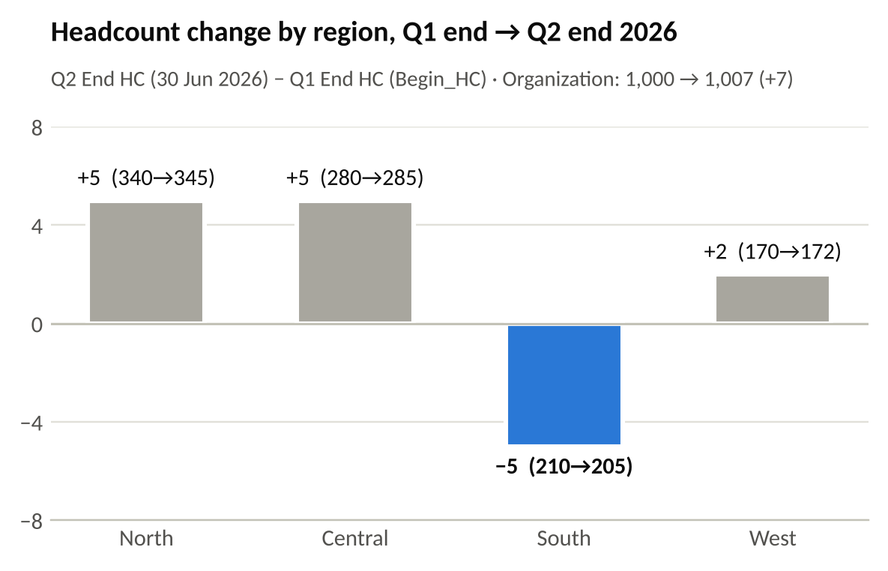
What this shows
- The organization grew by 7 (1,000 → 1,007), but that total hides a different local pattern: South is the only region that shrank (−5, −2.4%).
- South hired as many joiners as North (11 each) and more than Central (10) and West (5). Its decline comes from outflow: 15 voluntary leavers, against 3–5 in each other region.
- Every region reconciles exactly (residual 0). Transfers in (5) and out (2) do not net to zero across the four regions, which fits moves to or from units outside this population; this does not change the regional pattern.

4. Recruiting Evidence
Period: Q2 2026. Requisition volume, screened-to-interview conversion and time-to-fill by region. Conversion and requisition fill rate are shown in separate columns because they are different measures.
Region | Reqs open | Reqs filled | Req fill rate (filled ÷ open) | Candidates screened | Candidates interviewed | Screened-to-interview conversion (interviewed ÷ screened) | Avg time-to-fill (days)
North | 28 | 21 | 75.0% | 140 | 110 | 78.6% | 32
Central | 24 | 17 | 70.8% | 120 | 90 | 75.0% | 34
South | 36 | 18 | 50.0% | 135 | 75 | 55.6% | 45
West | 16 | 11 | 68.8% | 80 | 60 | 75.0% | 30
Organization | 104 | 67 | 64.4% | 475 | 335 | 70.5% | 35.7 (weighted)
Source: Recruiting_Summary!A3:G7. Fill rate is calculated for comparison only; it is not an approved project metric. Organization time-to-fill weighted by Requisitions_Filled.
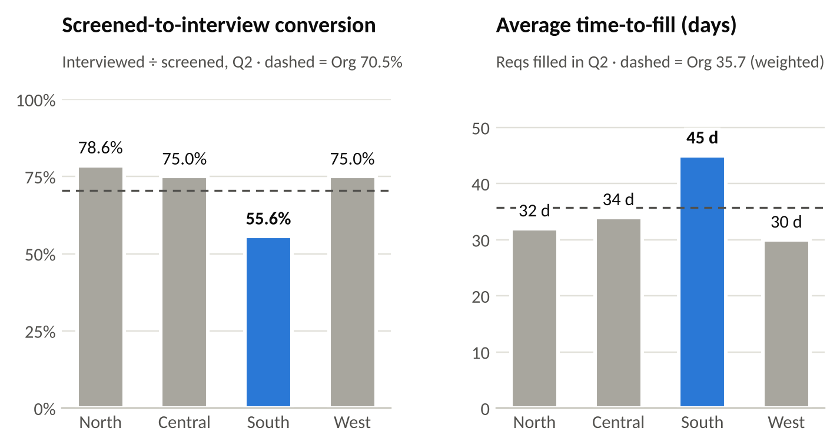
What this shows
- Conversion is not fill rate. Conversion = candidates interviewed ÷ candidates screened (approved metric). Fill rate = requisitions filled ÷ requisitions open. For South these are 55.6% and 50.0%: different numerators, different denominators.
- South has the most open requisitions (36) even though it is the third-largest region, the lowest conversion (55.6% vs 75.0–78.6% elsewhere; organization 70.5%), filled half its requisitions (18 of 36), and has the longest time-to-fill (45 days vs 30–34 elsewhere; organization 35.7).
- South’s recruiting throughput is weaker, but its hiring volume was not lower (Section 3). The data does not show how many of South’s open requisitions are backfills.

5. Attrition Evidence
Period: Q2 2026. Approved denominator: beginning-of-quarter population (Begin_Population = Q1 end headcount). Rate and population are shown together.
Region | Beginning population (Q1 end) | Voluntary separations (Q2) | Voluntary attrition rate | Share of beginning population | Share of voluntary separations
North | 340 | 5 | 1.5% | 34.0% | 18.5%
Central | 280 | 4 | 1.4% | 28.0% | 14.8%
South | 210 | 15 | 7.1% | 21.0% | 55.6%
West | 170 | 3 | 1.8% | 17.0% | 11.1%
North + Central + West | 790 | 12 | 1.5% | 79.0% | 44.4%
Organization | 1,000 | 27 | 2.7% | 100% | 100%
Source: Attrition_Summary!A3:D7; Voluntary_Sep cross-checked to Workforce_Movement Leavers_Voluntary. Shares and the combined row calculated from the same counts.
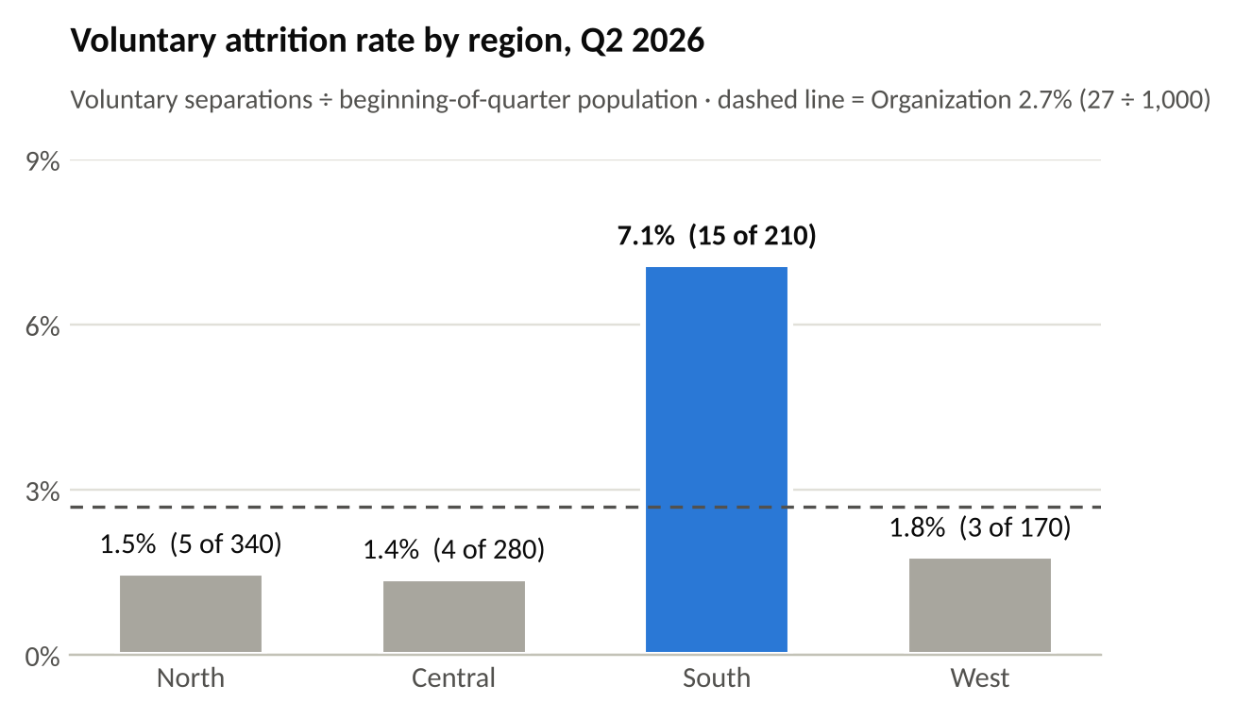
What this shows: the elevated pattern is concentrated, not broad
- North, Central and West sit in a narrow 1.4–1.8% band (12 of 790 combined = 1.5%). South is 7.1% (15 of 210).
- South holds 21% of the beginning population but accounts for 56% of voluntary separations (15 of 27).
- At the other regions’ combined rate, South would have had about 3 voluntary leavers; it had 15. Without South the organization rate would be 1.5%, so the 2.7% organization figure is lifted by one region.
- Involuntary separations (6 in total) are excluded, as the approved definition requires.

6. Compensation Evidence
Comparison controls: Region × Job Level (all groups are L3). Regions are compared with each other at the same job level, with sample size shown per group.
Region | Job level | Sample size (n) | Avg compa-ratio | Standard deviation | ±1 SD range
North | L3 | 62 | 1.02 | 0.05 | 0.97 – 1.07
Central | L3 | 48 | 0.99 | 0.06 | 0.93 – 1.05
South | L3 | 40 | 0.98 | 0.07 | 0.91 – 1.05
West | L3 | 36 | 1.01 | 0.06 | 0.95 – 1.07
All regions (reference only, not used for the regional comparison) | L3 | 186 | 1.00 (weighted by n) | 0.06 (pooled) | —
Source: Compensation_Summary!A3:D7. Organization reference value weighted by N_L3_Sample; pooled SD combines within- and between-region variation.
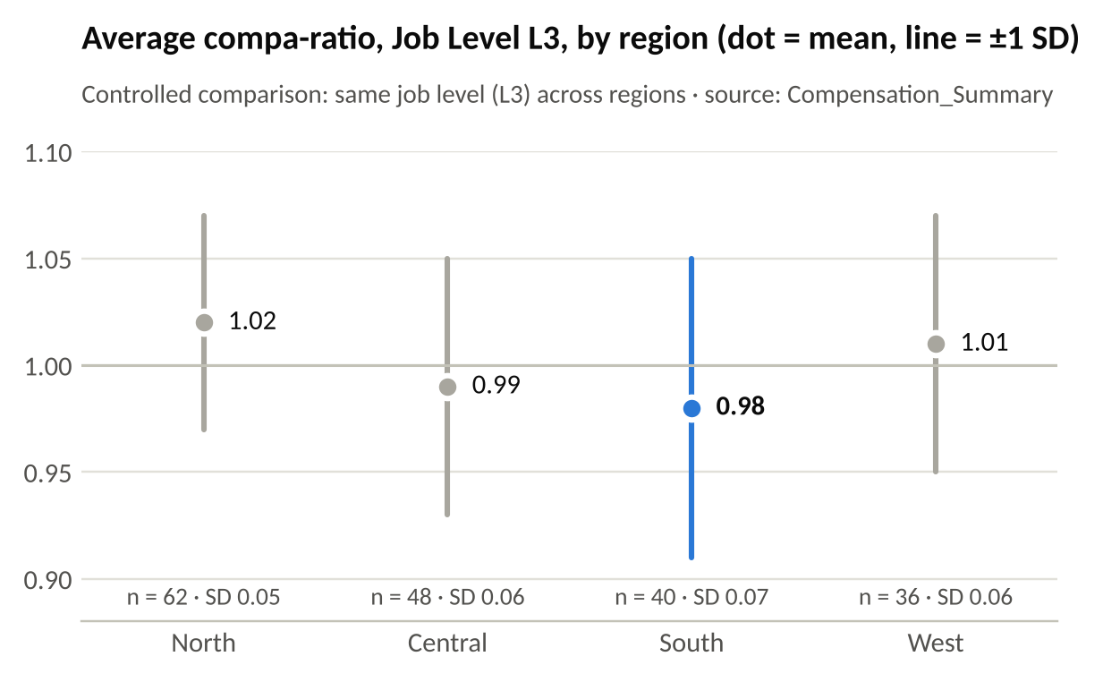
What this shows
- South’s L3 average compa-ratio is the lowest (0.98, n = 40). The 0.04 gap to North (1.02, n = 62) is about three standard errors at these sample sizes, so it is a real, detectable difference, not noise.
- The pay ordering does not line up with attrition. Central (0.99) cannot be told apart from South (gap 0.01, under one standard error), yet Central has the lowest voluntary attrition (1.4%).
- What this evidence cannot show: why anyone left. There is no exit-reason data, no market benchmark and no employee-level link between pay and leaving. Compensation is verified context, not an explanation for the attrition pattern.

7. AI-Assisted Interpretation Validation
Supplied AI-assisted interpretation (verbatim)
“South is the standout region. Voluntary attrition is highest (7.1%), Screened-to-Interview conversion is lowest (55.6%), Average Time-to-Fill is longest (45 days), and Backlog per FTE is roughly double the other regions (6.8). Compensation is also the lowest — South’s Avg Compa-Ratio is 0.98, which explains why people are leaving.”

# | Statement | Decision | Evidence-based reason
1 | “South is the standout region.” | Accept | South differs most from the other regions on headcount change, attrition, conversion, time-to-fill and backlog (Sections 3–5).
2 | “Voluntary attrition is highest (7.1%).” | Accept | 15 ÷ 210 Begin_Population = 7.1% on the approved denominator. Next highest is West (1.8%); organization 2.7%. (Attrition_Summary)
3 | “Screened-to-Interview conversion is lowest (55.6%).” | Accept | 75 ÷ 135 = 55.6% vs organization 70.5% (335 ÷ 475). This is conversion, not requisition fill rate. (Recruiting_Summary)
4 | “Average Time-to-Fill is longest (45 days).” | Accept | 45 days vs 30–34 in other regions; organization 35.7 days weighted by requisitions filled.
5 | “Backlog per FTE is roughly double the other regions (6.8).” | Accept | 6.8 vs 3.2–3.6; the other three average 3.4, so 6.8 is 2.0×. Note: business measure for Escalations Ops only, read as context. (Business_Context)
6 | “Compensation is also the lowest — South’s Avg Compa-Ratio is 0.98.” | Accept (descriptive fact) | 0.98 is the lowest L3 average (n = 40, SD 0.07). The 0.04 gap to North is real at these sample sizes. (Compensation_Summary)
7 | “…which explains why people are leaving.” | Reject | Unsupported causal claim. No supplied evidence links compensation to the attrition pattern: there is no exit-reason data, no market benchmark and no employee-level link. The package is descriptive and cannot show cause.  It also ignores contradicting evidence: Central’s L3 compa-ratio (0.99) cannot be distinguished from South’s, yet Central has the lowest attrition (1.4%). A difference can be real and still explain nothing.

Revised wording for statement 7
“South’s L3 average compa-ratio (0.98, n = 40) is the lowest of the four regions. The supplied evidence does not show whether compensation contributes to South’s voluntary attrition; exit-reason and market-benchmark data would be needed to test that.”
Overall decision on the supplied interpretation: Revise. Statements 1–6 are supported and kept; statement 7 is rejected and replaced with the wording above. The AI statement was tested against the workforce evidence, not used as evidence in itself.
Source: ai_assisted_interpretation; tested against Region_Summary, Attrition_Summary, Recruiting_Summary, Compensation_Summary, Business_Context and the metric_definition_pack.

8. Integrated Workforce Finding
Finding
The most decision-relevant pattern for current staffing pressure is concentrated voluntary attrition in South. South holds 21% of the beginning population but accounts for 56% of Q2 voluntary separations (15 of 27); its 7.1% rate is nearly five times the 1.5% rate of the other three regions combined. It is the only region whose headcount fell (−5), and the movement arithmetic shows why: its joiners matched North’s, but its voluntary leavers did not. Answer to the leadership question: South needs the most immediate follow-up, and the pattern is a combination of factors led by attrition concentration, with weaker recruiting throughput as a secondary pressure.

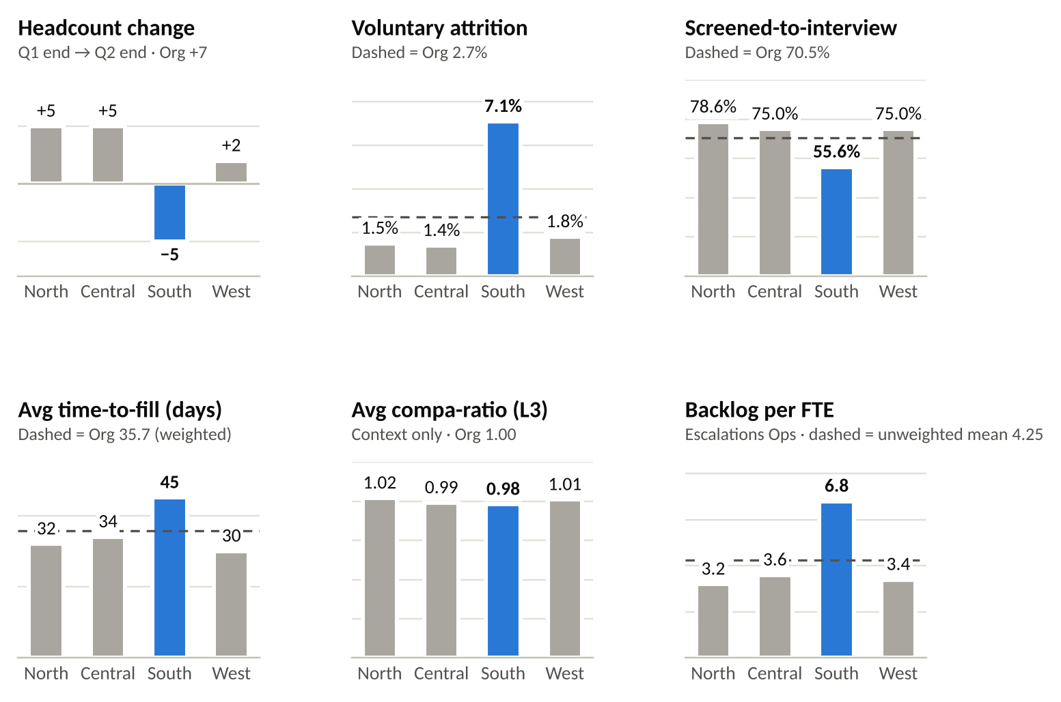
South (blue) against the other regions on every measure in the package, Q2 2026. Each panel has its own scale. Built from Region_Summary using the approved roll-up rules.
Role in the finding | Evidence | What it shows
Primary pattern | Voluntary attrition (Section 5) | 7.1% vs 1.4–1.8% elsewhere; 56% of voluntary separations from 21% of the population.
Supporting evidence | Headcount movement (Section 3) | Only region to shrink (−5). The decline is accounted for by voluntary outflow, not by lower hiring volume.
Secondary pressure | Recruiting throughput (Section 4) | Lowest conversion (55.6%), 18 of 36 requisitions filled, 45-day time-to-fill. Slows replacement of leavers; adds to the pressure but does not explain the outflow.
Business context | Backlog per FTE (Escalations Ops) | 6.8 vs 3.2–3.6 elsewhere. The staffing pressure is visible operationally; this does not show that attrition caused the backlog.
Context only | Compensation (Section 6) | Lowest L3 compa-ratio (0.98) by a real margin, but no evidence links it to attrition.

Why this pattern deserves follow-up ahead of the alternatives
- It is the largest departure from the other regions: attrition 7.1% vs 1.5% (about 4.7×). Conversion (55.6% vs 76.5% in the other regions) and time-to-fill (45 vs 32.2 days) also differ, but by less.
- It accounts arithmetically for South’s headcount decline. South’s joiner volume matched North’s; the difference is outflow.
- The alternatives each give an incomplete answer. Headcount alone hides it (organization +7). Recruiting alone describes slower replacement but not the concentrated outflow. Compensation cannot carry the finding without causal evidence.
Descriptive guardrail: these patterns occur together in one quarter. This package does not establish what is causing South’s attrition, nor that attrition caused the backlog.

9. Follow-Up Action Comparison
Criterion | A. Targeted South attrition diagnostic | B. South recruiting acceleration | C. Market pay adjustment for South L3
What it involves | Review exit records for the 15 Q2 voluntary leavers in South; structured stay conversations with current South Escalations Ops staff; readout with options. | Recruiting Operations review of the South funnel (screening criteria, interview capacity, requisition priority) to lift conversion and cut time-to-fill. | Raise South L3 pay toward the other regions.
How directly it responds to the evidence | Directly. Targets the primary pattern: concentrated voluntary attrition. | Partly. Addresses the secondary pressure (slower replacement), not the concentrated outflow. | Weakly. Responds to the rejected causal claim (Section 7), not to verified evidence.
Fit to the current level of certainty | Strong. We know where attrition is concentrated but not why; this collects the “why” before resources are committed. Low cost, fast, reversible. | Moderate. The recruiting gap is well evidenced, but on its own this refills roles without addressing why leavers are concentrated in South. | Poor. No exit-reason or market-benchmark evidence that pay drives leaving. Costly and hard to reverse.
Who could realistically own it | South HR business partner, with the South regional leader. | Recruiting Operations lead (South). | Total Rewards / Compensation lead.
Additional evidence still needed | Exit-interview or exit-survey records; stay-conversation themes; leaver profile (function, tenure, team, month). | Stage-level funnel data; which open requisitions are backfills. | Market benchmark for South L3 roles; exit reasons that cite pay.
Assessment | Recommended | Useful follow-on; not the first action. | Not recommended now. Revisit only if Option A finds pay-related exit reasons.

10. Recommended Action and Owner
Element | Detail
Recommended action | Option A: targeted South voluntary-attrition diagnostic.  (1) Review exit-interview / exit-survey records for the 15 Q2 voluntary leavers in South, profiled by function (including Escalations Ops), tenure, team and month of exit.  (2) Hold structured stay conversations with a sample of current South Escalations Ops employees.  (3) Give the South regional leader a short readout with the follow-up options the findings support, coordinating with Recruiting Operations on open South requisitions.
Accountable owner | South HR business partner
Sponsor / decision-maker | South regional leader. Receives the readout and decides on any resulting actions.
Timing | Start immediately after this Q2 2026 review; readout within 30 days; re-check South voluntary attrition against the Q2 baseline (7.1%) at the Q3 2026 review.
Why this action | It matches the strength of the evidence. The data shows clearly where attrition is concentrated but not why. A diagnostic is quick, low cost and reversible, and it produces the evidence needed before larger commitments such as pay changes or workload restructuring.

11. Limitation or Next Evidence Need
Material limitation
The evidence is descriptive and covers a single quarter of attrition. It shows where voluntary attrition is concentrated, but not why people left, and with no Q1 attrition baseline it cannot show whether South’s 7.1% is a new spike or a persistent pattern.

Next evidence needed
- Exit reasons for the 15 South voluntary leavers (exit interviews or exit surveys).
- Q1 2026 and earlier voluntary attrition by region, to establish whether the pattern is new.
- Escalations Ops FTE by region, to weight Backlog per FTE and confirm it matches the HR population.

12. Copilot-Use Record
Record for every Copilot-assisted step (also entered in the workbook’s Copilot_Record sheet). The supplied ai_assisted_interpretation is not a learner Copilot step; it is validated in full in Section 7.
Field | Copilot step 1 — Copilot in Excel
Analysis step | Name the step, e.g. “Summarize the Region_Summary comparison”
Exact prompt | Paste the exact prompt you used. Suggested: “Using the Region_Summary table, describe how each region compares with the others on each measure. Do not explain causes.”
Copilot output (verbatim) | Paste Copilot’s exact output
Decision | Accept / Revise / Reject
Evidence-based reason | What you checked against Region_Summary and the metric_definition_pack: figures, roll-up rule, causal wording
What you changed | Edits made to the output, or “None”
Other AI assistance: an AI assistant (Claude, by Anthropic) was used to re-check calculations and draft text for this package. Every value was verified against prepared_workforce_workbook.xlsx and the metric_definition_pack before inclusion.

